LAB 10 - Cloud Computing Course Student Name:

Arshia Jadoon
Roll Number: 014
Course: CloudComputing Instructor:
Sir Waqas Saleem
Institution: FJWU

task1_gh_auth_login.png
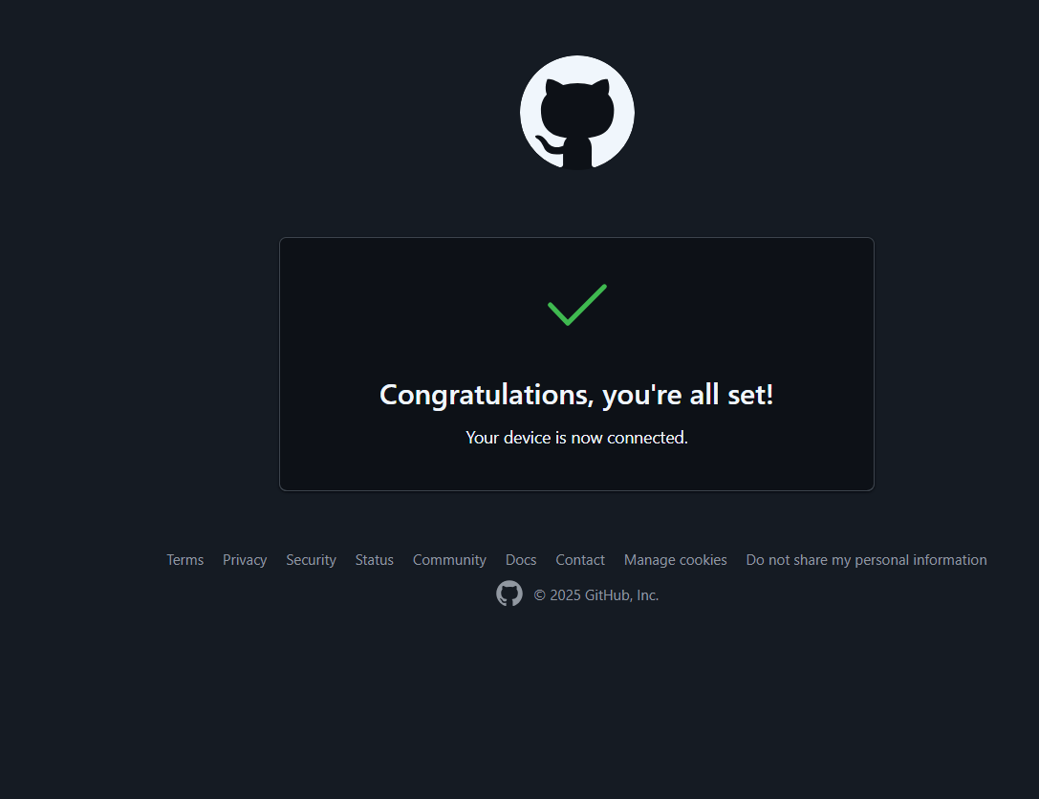
task1_codespace_list.png
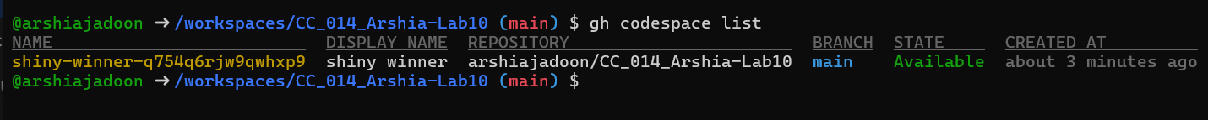
task1_codespace_ssh_connected.png
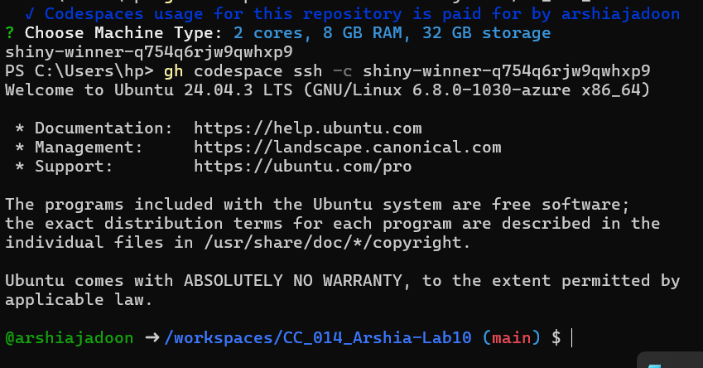
task2_aws_install_and_version.png
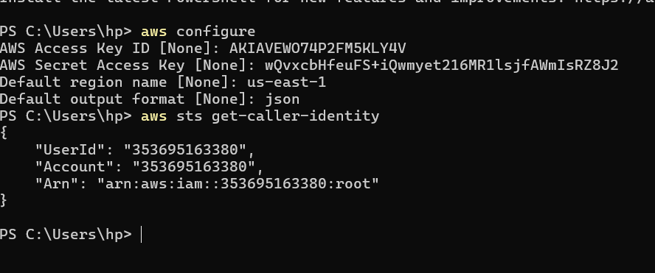
task2_aws_configure_and_files.png
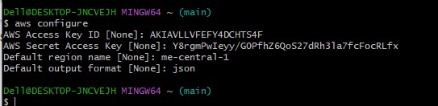
task2_aws_get_caller_identity.png
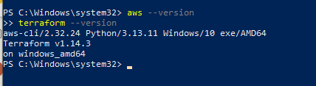
task2_terraform_install_and_version.png
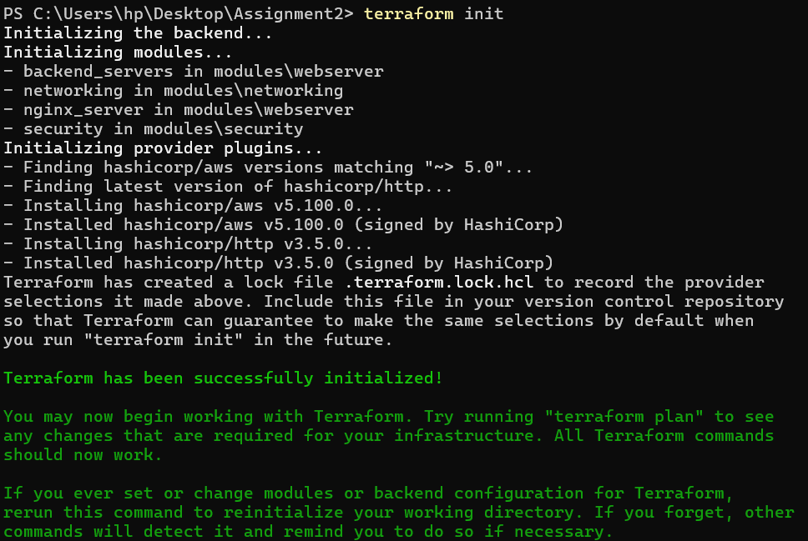
task2_provider_file_creation.png
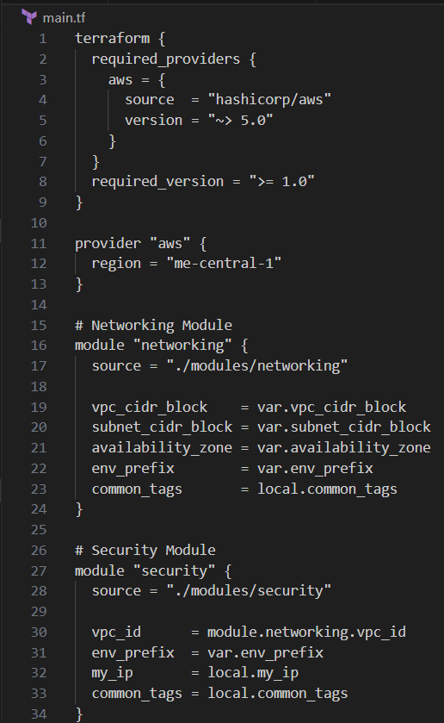
task2_provider_block.png
task2_terraform_init_output.png
task3_main_tf_resource_add.png
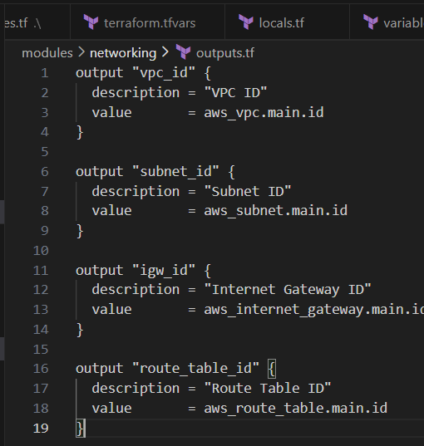
task3_terraform_apply_vpc_subnet.png
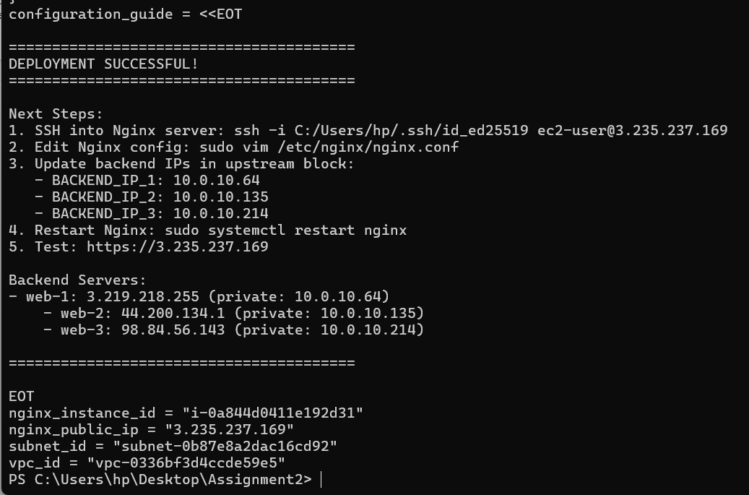
task3_aws_cli_verify_subnet.png
task3_aws_cli_verify_vpc.png
task4_terraform_apply_datasource_resource.png
task4_terraform_destroy_targeted.png
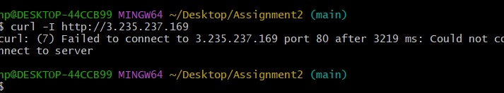
task4_terraform_apply_after_refresh.png
task4_terraform_destroy_all.png
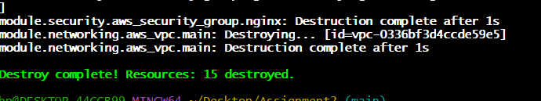
task4_terraform_plan_output.png
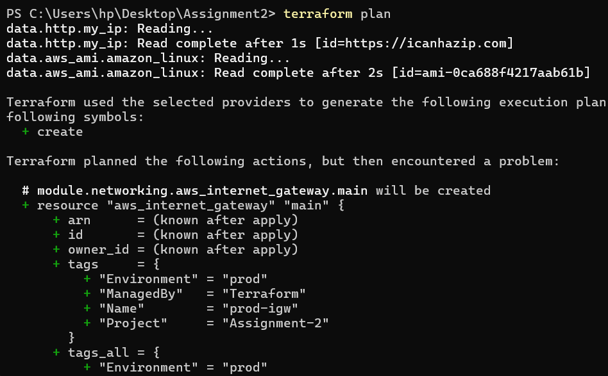
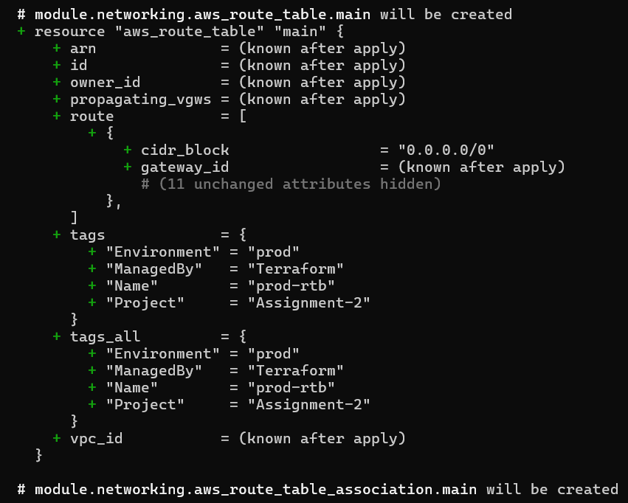
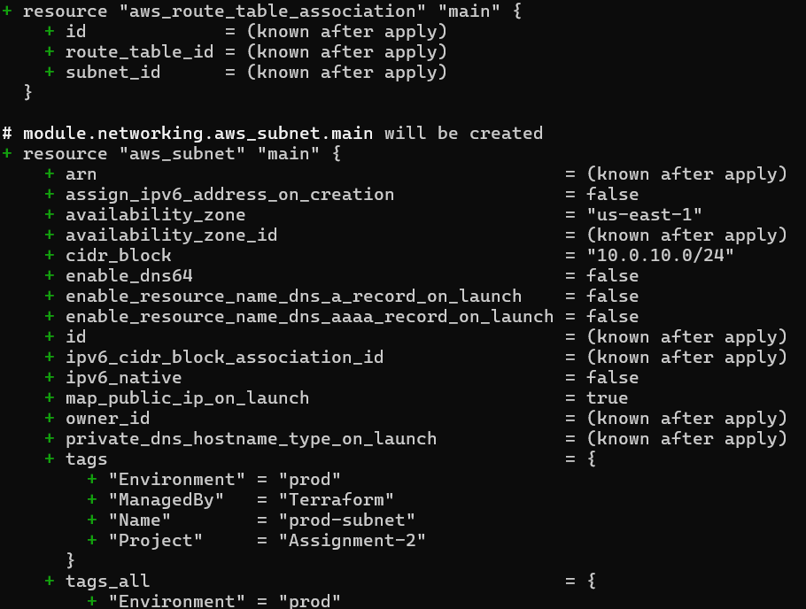
task4_terraform_apply_after_destroy.png
task4_terraform_apply_tagging.png
task4_terraform_plan_remove_tag.png
task4_terraform_apply_remove_tag.png
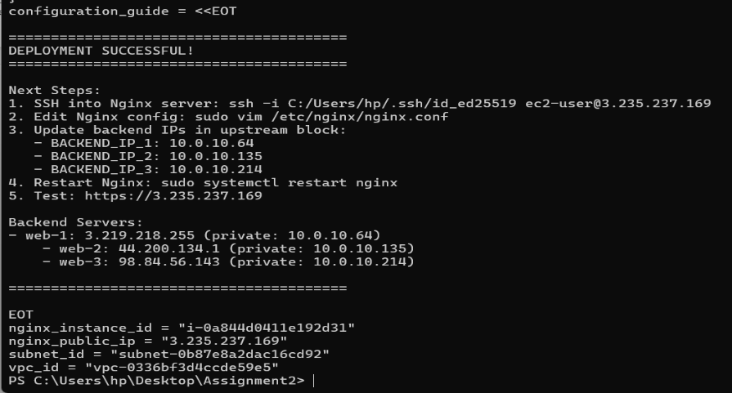
task5_terraform_destroy.png
task5_terraform_state_file_empty.png
task5_terraform_state_backup_prev.png
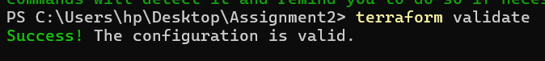
task5_terraform_apply_recreated.png
task5_terraform_state_file_populated.png
task5_terraform_state_backup_empty.png
task5_terraform_state_list.png
task5_terraform_state_show_resource.png
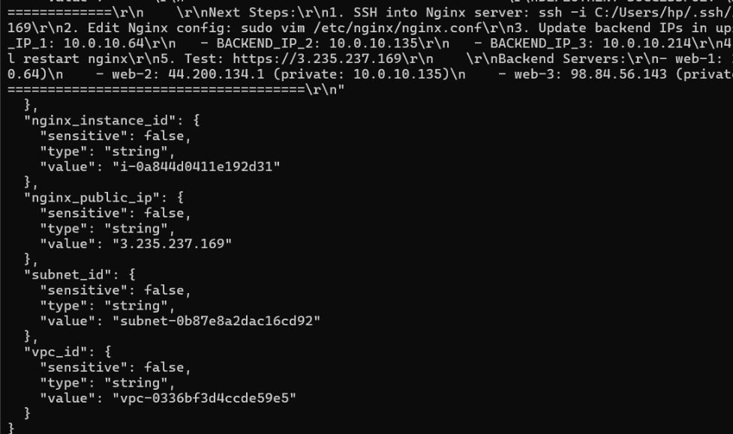
task6_terraform_outputs_basic.png
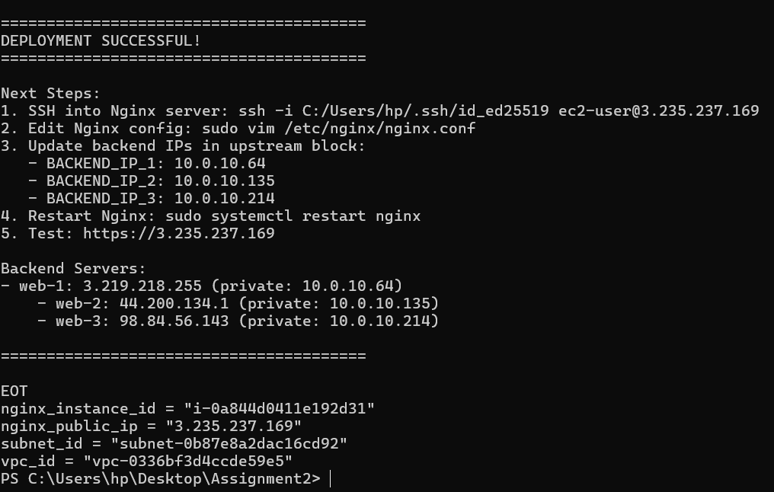
task6_expanded_outputs.png
cleanup_destroy_resources.png

